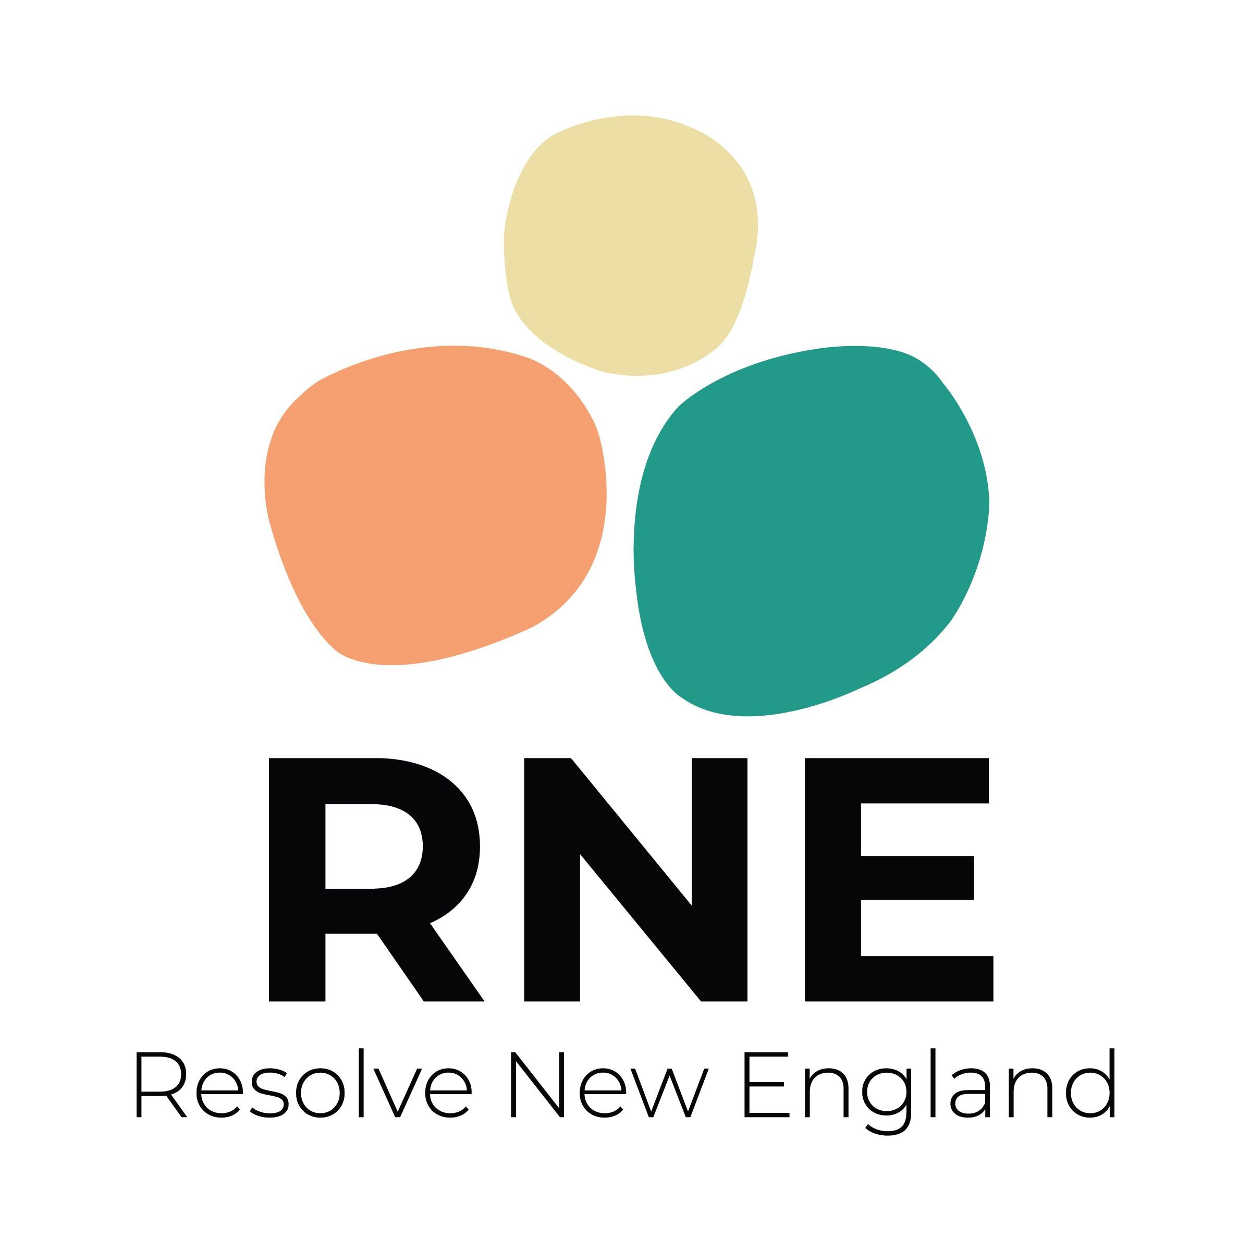

BOARD NOMINATION FORM

I am interested in serving on the board of directors for Resolve New England.

Name: Meredith Wheeler

Address: 16 Loxley Rd.
Providence, RI 02908

Phone(s): 413-834-3234

Email: memunn@bu.edu

Please write one to two paragraphs describing the strengths you would bring to the board:

I am passionate about ensuring that others have an easier time accessing fertility care than I did, especially as a queer woman with both medical and social infertility. I am a strategic thinker with a lot of professional experience in the health advocacy space, and the drive to get things done. In work and volunteer contexts I’m one of the people who raises my hand and makes time for the work outside of regular meetings - and I understand that effective boards and committees require dedication and time commitment from their members.

I have strong writing and meeting facilitation skills, am organized, and am always willing to help out. I am an ideas person, and you can always count on me for a good brainstorm. I also love a good laugh to make a long meeting more fun.

Please list other work or involvement in the family building/fertility community and field that might pertain to your work with RNE:

In addition to my first-hand experience with infertility and recurrent pregnancy loss, I served for several years as a moderator of a large international infertility and fertility treatment oriented support community and had exposure to many different experiences and diagnoses within the community as well as provided a lot of education on some unique factors that impact LGBTQ+ fertility and family-building. I was part of the Rhode Islanders for Parentage Equality coalition as an impacted parent and am well-connected within the LGBTQ+ and LGBTQ parenting communities in MA and RI.

I also have 15 years of professional experience working in health policy advocacy (primarily in Medicaid), LGBTQ+ equity and policy inclusion, and in cancer care, including areas that touch on fertility preservation.

Thank you for taking the time to complete this form. The board will review your nomination soon and will contact you shortly. If you have any questions you may contact Kate Weldon LeBlanc, Executive Director (kwleblanc@resolvenewengland.org or 617-686-8465) or Jennifer Redmond, Board Chair (jennifer@jennredmond.com).

